**CCN – Lecture 1**

The human brain:

* Neurons: 100 billion (10^11)
* Synapses: 10.000/neuron (10^15)
* Glia: 100 billion (10^11)
* Energy: +- 20W

…

…

…

1. Sympathetic system (uses the neurostransmitter norephinephrine)

Activation of this system increases heart rate, etc and prepares the body for action(fight or flight) by stimulating the adrenal glands to release adrenaline.

1. Parasympathetic system (uses acethylcholine as its transmitter)

Activation of this system slows heart rate, stimulates digestion, etc and helps the body with functions germane to maintaining the body.

The two system operate antagonistically.

The CNS is made of the delicate brain and spinal cord. Each encased in its protective bony shell and suspended in a sea of cerebrospinal fluid(CSF). They are covered with three protective membranes-the meninges:

1. The outer membrane: *dura mater*
2. The middle one: *arachnoid mater*
3. The inner one(most delicate one)(adheres to the surface of the brain): *pia mater*

In the CNS, neurons are bunched together in various ways. 2 of the most organizational clusters are in a *nucleus* or in a *layer*.

A *nucleus* is a compact arrangement of nerve cell bodies and their connections. 100 to millions of neurons with functionally similar inputs and outputs. Located throughout both the brain and the spinal cord.

The outer layer of the brain, the cerebral cortex, has billions of neurons arranged in layers of thin sheets, folded across the surfaces of the cerebral hemispheres. The *gray matter* is composed of neuronal cell bodies. *The white matter* is composed of axons and glial cells. These axons are groups together in tracts that run in association tracts from one region to another within a hemisphere, or may cross into the other hemisphere in tracts called commissures like the nerves un the PNS.

* The central nervous system consists of the brain and spinal cord. The peripheral nervous system consists of all nerves and neurons outside of the central nervous system.
* The autonomic nervous system is involved in controlling the action of smooth muscles, the heart, and various glands. It includes the sympathetic and parasympathetic systems.
* The sympathetic system uses the neurotransmitter norpinerphrine. This system increases heart rate, diverts blood from digestive tract to the somatic musculature, and prepares the body for fight-or-flight responses by stimulating the adrenal glands.
* The parasympathetic system uses acetylcholine as a neurotransmitter. It is responsible for decreasing heart rate and stimulating digestion.
* Groups of neurons are called ganglia.
* The cerebral cortex is a continuous sheet of layered neurons in each hemisphere.
* The axons of cortical neurons and subcortical ganglia travel together in white matter tracts that interconnect neurons in different parts of the brain and spinal cord.
* The corpus callosum is the main fiber tract that connects the two hemisphere of the brain.

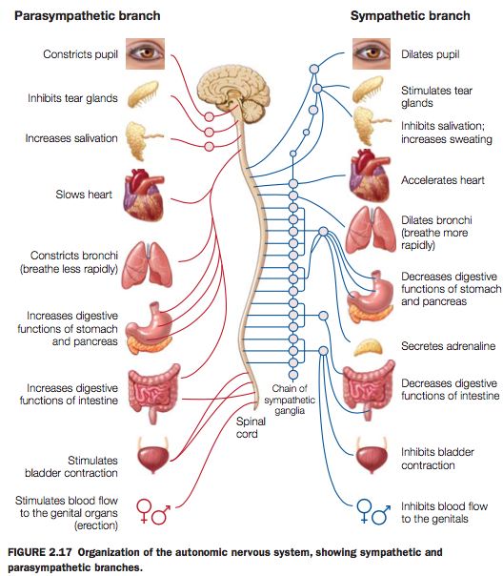

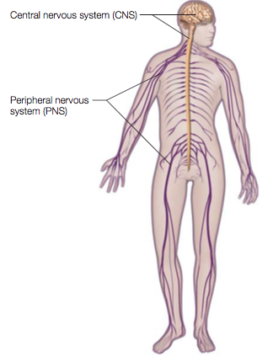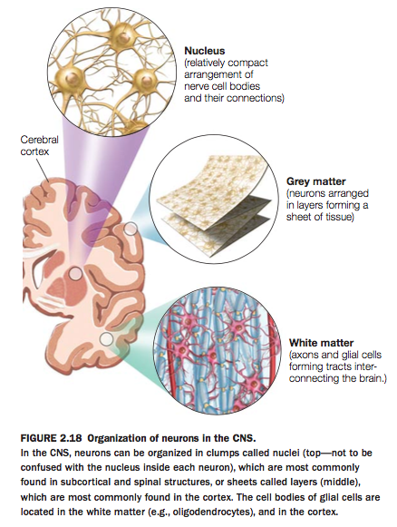

* The hindbrain is composed of the medulla pons (basic functions like breathing control- and the cerebellum (motor but also cognitive functions)

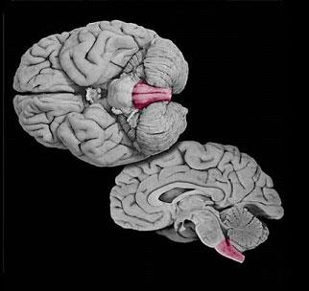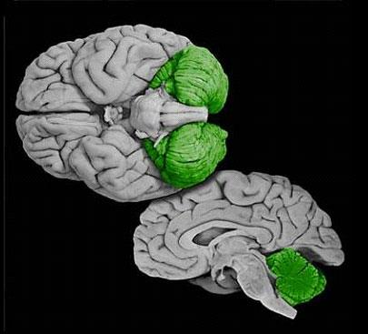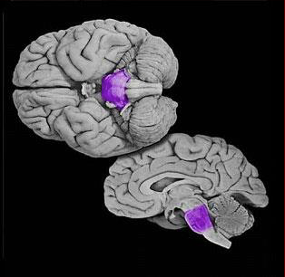

* The spinal cord conducts the final motor signals to the muscles, and it relays sensory information from the body’s peripheral receptors to the brain.
* The brainstem’s neurons carry out many sensory and motor processes, including visuomotor, auditory and vestibular functions as well as sensation and motor control of the face, mouth, throat, respiratory and motor control.
* The brainstem houses fibers that pass from the cortex to the spinal cord and cerebellum, and sensory fibers that run from spinal levels to the thalamus and then the cortex.
* Many neurochemical system have nuclei in the brainstem that project widely to the cerebral cortex, limbic system, thalamus, and hypothalamus.
* The cerebellum integrates information about the body and motor commands that modifies motor outflow to effect smooth, coordinated movements.

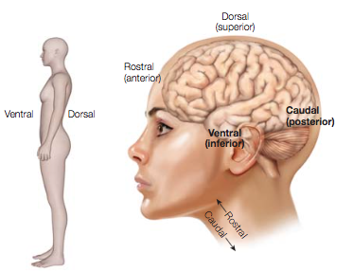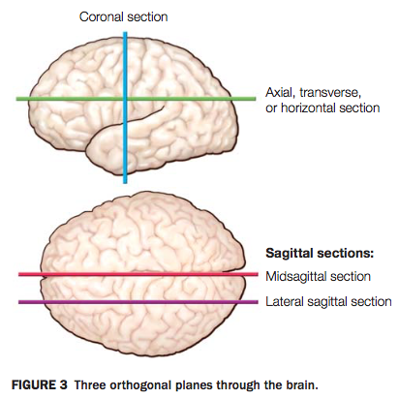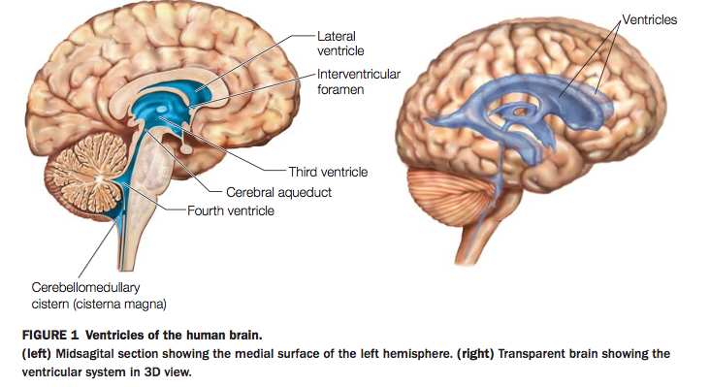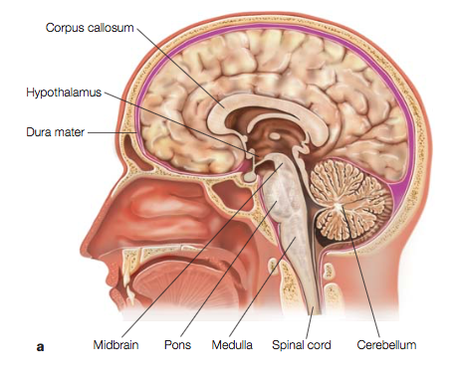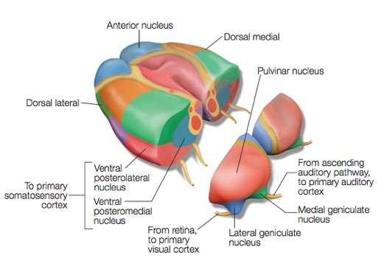

* The thalamus is the relay station for almost all sensory information.
* The hypothalamus is important for the autonomic nervous system control and endocrine system (hormone). It controls functions for the maintenance of homeostasis (fatigue, hunger, body’s temperature, etc). It is also in control of the pituitary gland.
* The pituitary gland releases hormones in the bloodstream where they can circulate to influence other tissues and organs (e.g. gonads).
* The limbic system includes subcortical and cortical structures that are interconnected and play a role in emotion (+memory). Example: Henry Molaison.

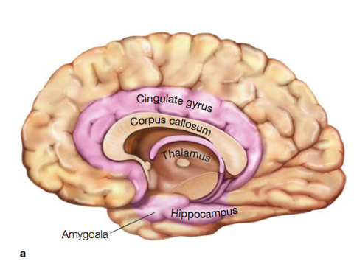

* The basal ganglia are involved in a variety of crucial brain functions including actions selections, actions gating, reward-based learning, motor preparation, timing, task switching, and more. (motor control and learning) -Parkinson disease – deep brain stimulation.

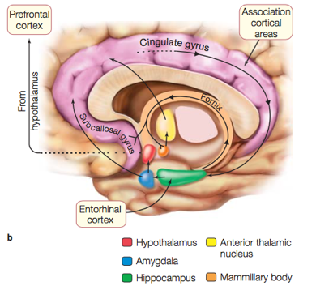

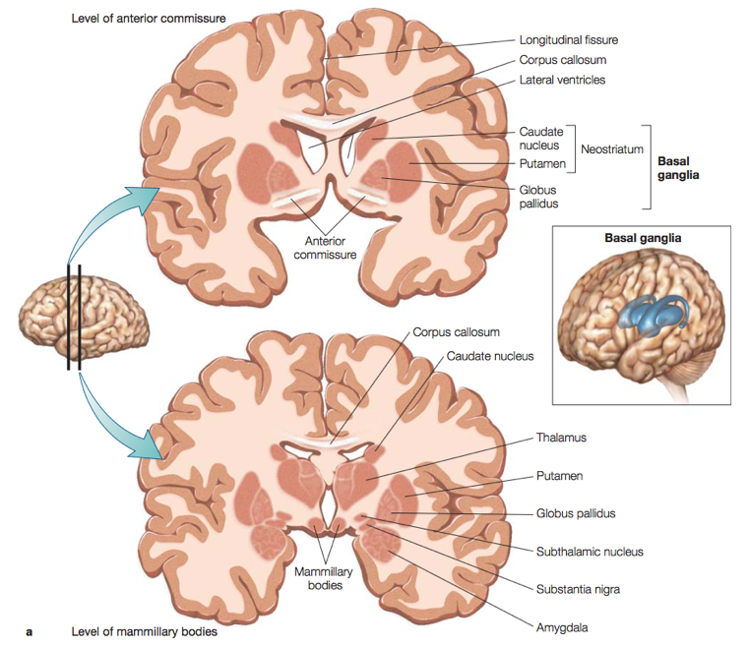

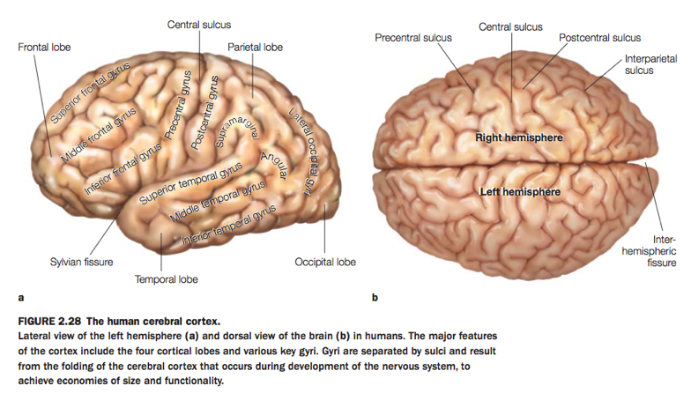

* Gyri are the protruding areas seen on the surface of the cortex; sulci, or fissures, are the enfolded regions of cortex.
* Brodman divided the brain into 52 distinct regions based on the underlying cytoarchitectonics (architecture of the cells).
* The lobes of the brain include the frontal, parietal, temporal and occipital lobes.
* The frontal lobe is for planning, cognitive control, execution of movements, personality, language (production). The parietal lobe receives sensory input about touch, pain temperature, and limb position, and it is involved in coding space and coordinating actions (attention, sensorimotor – higher order vision – somatosensory cortex).

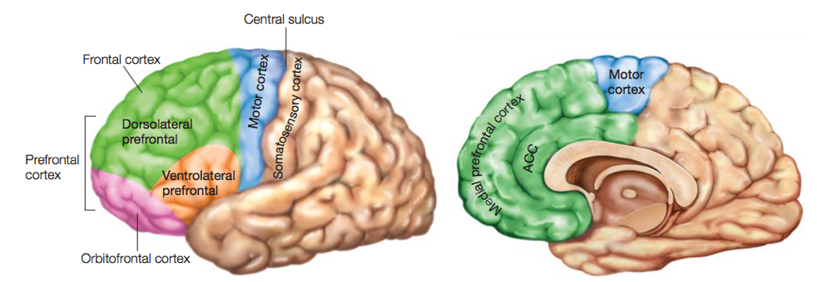

* The temporal lobe contains auditory, visual, and multimodal processing areas. The occipital lobe processes visual information, auditory cortex, memory, language (perception). The limbic lobe (not really a lobe) is involved in emotional processing, learning, and memory.

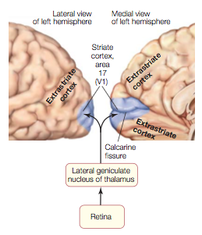

* Topography is the principle that the anatomical organization of the body is reflected in the cortical representation of the body, both in the sensory cortex and motor cortex.
* Association cortices are those regions of cortex outside the sensory specific and motor cortical regions. Association cortex receives and integrates input from multiple sensory modalities.

